2024 KTB Youth Summer Reading Log
Keep track of how much you read each week by typing the minutes in each box. A minimum of 60 minutes per week is required for entry for the Grand Prize Drawing. Once this document is completed, save it. Then attach and email it to KTB@ks.gov.
NAME:____________________________________________________

June 3 – 7
June 10 – 14
June 17 – 21
June 24 – 28
July 1 – 5
July 8 – 12
July 15 – 19
July 22 – 26
July 29 – Aug 2

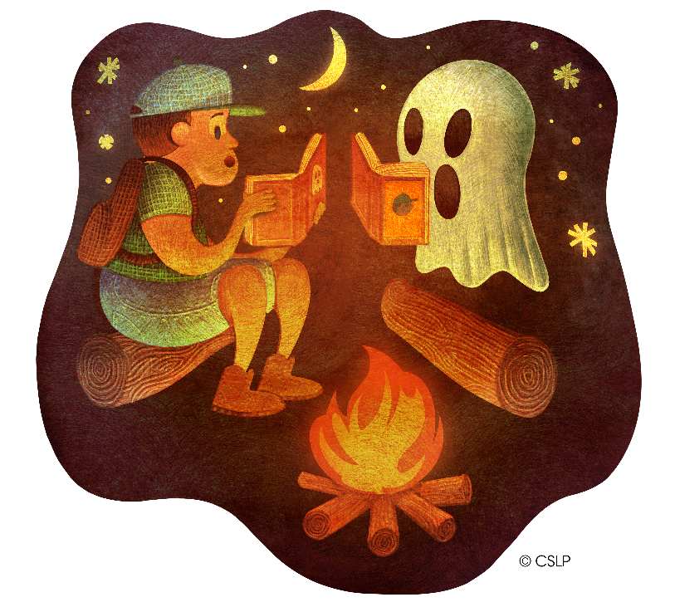
Remember! You must submit your reading log by Monday, August 12, to be eligible for the grand prize drawing!

