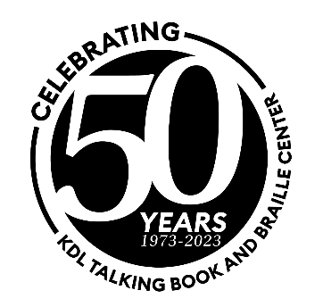
2023 NLS Midlands Regional Conference:

Unity in Diversity

May 16-18, 2023

Grand Rapids, Michigan

Conference Agenda

Tuesday, May 16, 2023
9:00 AM Registration/Networking
9:30 AM Housekeeping/Roll Call of the States - Shelley Roossien, Kent District Library Talking Book & Braille Center
9:50 AM Welcome – Lance Werner, Kent District Library
10:15 AM Keynote: Changing Perspective and Creating Opportunities: How Accessibility and Equity are Key! – Jon Cauchi, Disability Advocates
11:15 AM Break
11:30 AM LBPH Wiki – Katie Monkiewicz, Washtenaw Library for the Blind & Print Disabled at AADL
12:00 PM Lunch on your own
1:00 PM EDI Tagging: Maintaining a Diverse Collection – Samantha Hodge & Marie Mulder, Kent District Library
2:00 PM Newsline Update – Scott White, National Federation for the Blind
2:30 PM Open Forum: Outreach
3:00 PM Break
3:15 PM Meet in Lobby for Grand Rapids Public Museum Tour
3:30 PM Grand Rapids Public Museum Tour or explore Grand Rapids on your own

Wednesday, May 17, 2023
9:00 AM Registration/Networking
9:15 AM NLS Updates – Pam Davenport & Jason Broughton, NLS
10:00 AM Open Forum: Meet the Director – Jason Broughton
10:30 AM Break
10:45 AM VA Rapid Sign-up – Caitlin Wolfe, Braille & Talking Book Library
11:00 AM Finding the Way: How to Help a Visually Impaired Person With Their Orientation and Mobility – Amber Strasz, Mobility Specialist
12:00 PM Lunch sponsored by Keystone
1:00 PM be nice. To Yourself – Christy Buck, Founder of be nice.
2:00 PM Baking Something New for 2024: ALA-ODLOS and NLS Project for Revised Standards and Guidelines of Service for LOC Network of Libraries for the Blind and Print Disabled 2024 – Mandy Mattingly, Project Director
2:45 PM Break
3:00 PM Summer Reading – Stephanie Wambaugh, Braille & Talking Book Library
3:30 PM Open Forum – Braille eReaders
4:00 PM Midlands Business Meeting

Thursday, May 18, 2023
9:00 AM Registration/Networking
9:15 AM User Group Meetings
10:15 AM Break
10:30 AM VA Presentation – Deb Unseld & Paul Ryan, West Michigan Veterans Coalition
11:30 AM Closing Remarks
12:00 PM Adjourn

