State Library of Kansas, Talking Books

invites patrons to explore ocean depths by joining our
2022 Summer Reading program
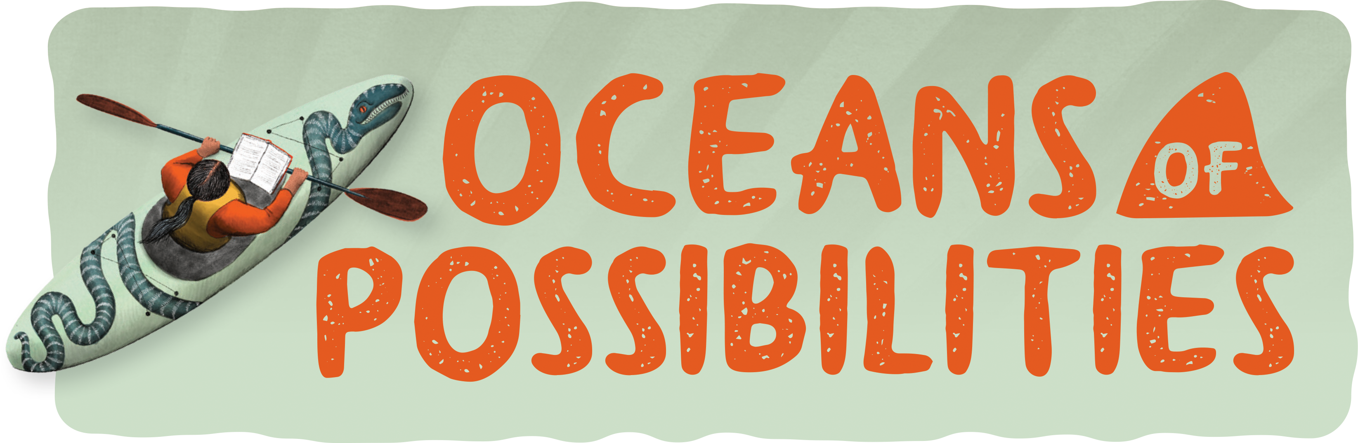
Starts: June 1st Ends: August 1st
- Just for signing up, your name will be placed in a weekly drawing for a $10 gift card.
- One grand prize winner from each age group will win a $50 gift card at the end of the summer.
- To be entered in the grand prize drawing, meet the minimum requirements and simply send in your reading log! A name will be randomly selected from those patrons who submit a reading log.
- Readers ages 17 and under will be entered in the youth program. Patrons 18 and older will participate in the adult program.
- We’ll have fun summer reading activities and book recommendations posted to our Facebook page and website throughout the summer.

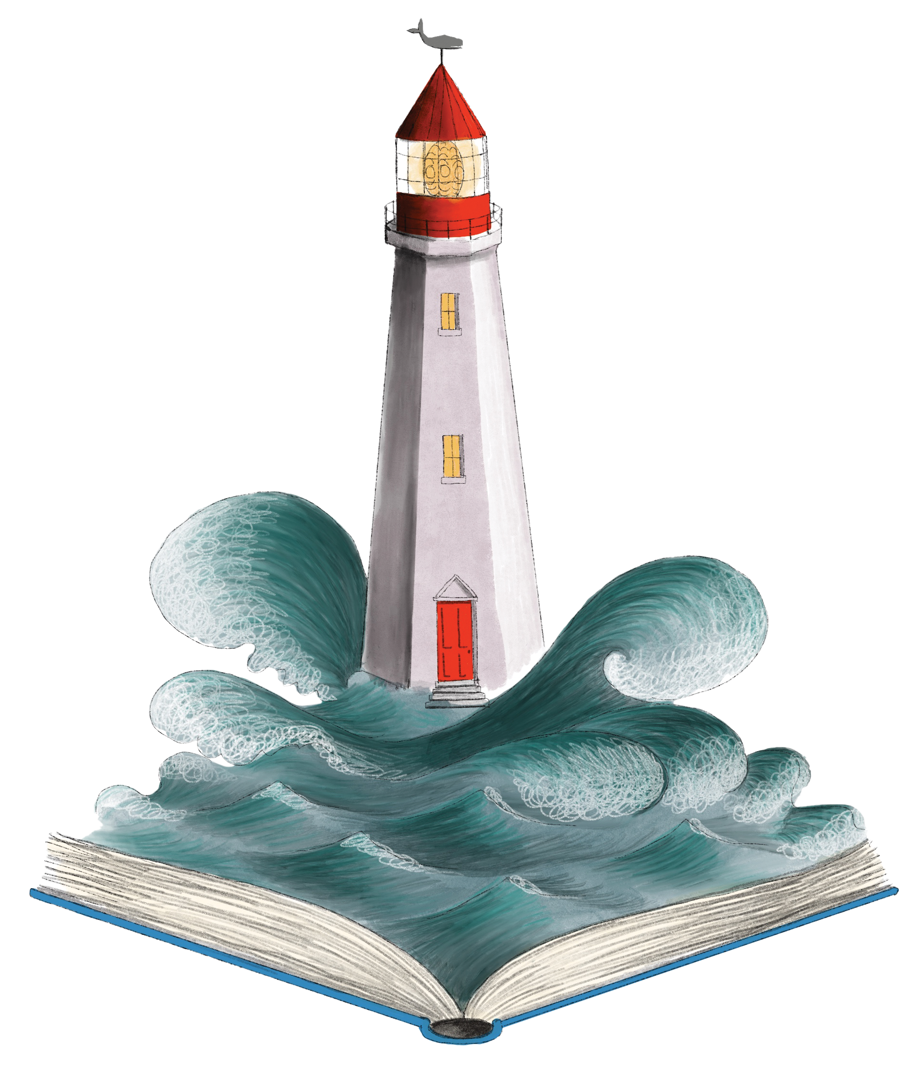Sign up for this exciting program by calling our office at 1-800-362-0699 or dropping us an email at KTB@ks.gov letting us know you are interested in the program.

It’s that easy!
When we receive your call or email, we’ll send an information packet to you with everything you need to get started!
We look forward to hearing from you!

