Braille and Talking Books @ Taylor Community Library
12303 Pardee Rd., Taylor, MI 48180
http://www.taylor.lib.mi.us 734-287-4840

Dear Patron:
Our records indicate that you have received replacement Talking Book Equipment but the faulty equipment has not been returned.
If you have already returned this equipment, please contact Braille and Talking Books @ Taylor Community Library at 734-287-4840 (or toll-free at 844-307-1621) to update your account.
Otherwise, please return the faulty equipment, which belongs to the United States Government.

Players:
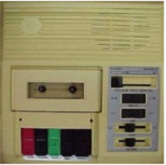 | 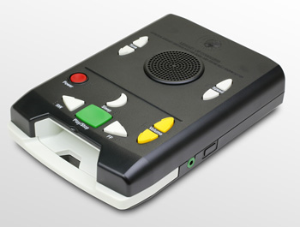 | 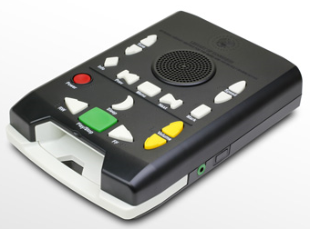
C01 | DS | DA

We have included a postage free mailing label for your convenience. Simply affix this label to the box that you use to return the equipment.
If you no longer have the equipment or have questions about returning it, please contact Braille and Talking Books @ Taylor Community Library at 844-307-1621.

