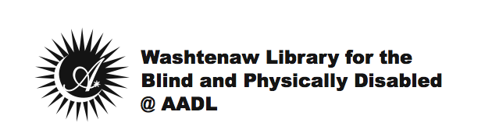
About Your New Digital Talking Book Machine and Digital Talking Books

Congratulations on receiving your new Digital Talking Book Machine (DTBM)! Audio instructions on how to use your new DTBM will begin playing as soon as you turn on your machine. If you have further questions on how to use your new DTBM, please feel free to call us at (734) 327-4224 for assistance.

This machine may not be loaned, sold, traded, dismantled or thrown away.

To maintain your new DTBM and DTBM service, please:
- Keep the machine in a clean, dry area.
- Plug it into an outlet to recharge the battery.
- Call WLBPD if you experience a malfunction.
- Never attempt to repair it yourself.
- Notify WLBPD if you move, wish to cancel service, or change your name.

Please return digital books within 60 days.
It is very helpful if you return your books within the 60-day loan period, so that other patrons may enjoy them too.

Want more books?
If you have access to the Internet, you may download books from BARD (Braille and Audio Reading Download) at www.bard.loc.gov. There you will find tens of thousands of books to choose from, and dozens of magazines too, with more being added every week.

To download books from BARD you will need:
- To apply.
- A high-speed Internet connection.
- An e-mail address.
- Knowledge of navigating the Internet, filling out online forms, as well as downloading and unzipping files.
- A flash drive (USB) or an SD memory card with card reader.

More information on BARD is available at:
http://wlbpd.aadl.org/wlbpd/bard

For one-on-one technology assistance, you may visit the WLBPD Assistive Technology Lab at the Downtown AADL on a walk-in basis on:
- Tuesdays 2:00 pm-6:00 pm
- Wednesdays 9:30 am-12:30 pm
- Thursdays 2:00 pm-5:00 pm

Washtenaw Library for the Blind & Physically Disabled
WLBPD @ AADL

- Email: wlbpd@aadl.org
- Phone: (734)327-4224
- Website: wlbpd.aadl.org

