Braille and Talking Books @ Taylor Community Library
12303 Pardee Rd., Taylor, MI 48180
http://www.taylor.lib.mi.us 734-287-4840

Dear Family:

We are very sorry to learn of your family member’s passing. We have stopped further mailings and ask for your help in locating the equipment and books belonging to the United States government.

Players:
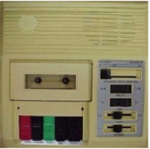 | 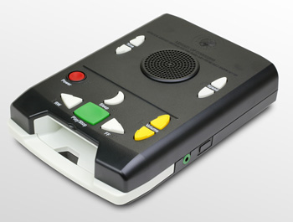 | 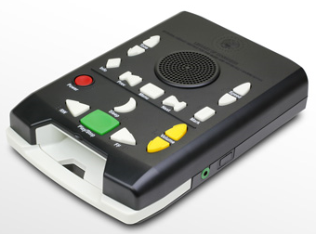 | 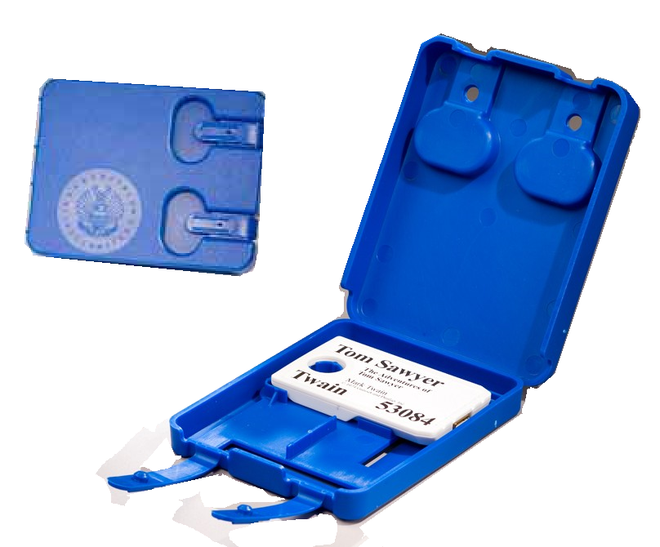
C01 | DS | DA | DB - See below

Book Cartridges:
DB | DB | DB | DB
DB | DB | DB | DB
DB | DB | DB | DB

We have included a postage free mailing label for your convenience. Simply affix this label to the box that you use to return the equipment.

If you cannot locate the equipment or have questions about returning it, please contact Braille and Talking Books @ Taylor Community Library at 734-287-4840 or State of Michigan Braille and Talking Book Library at 800-992-9012. Thank you.

