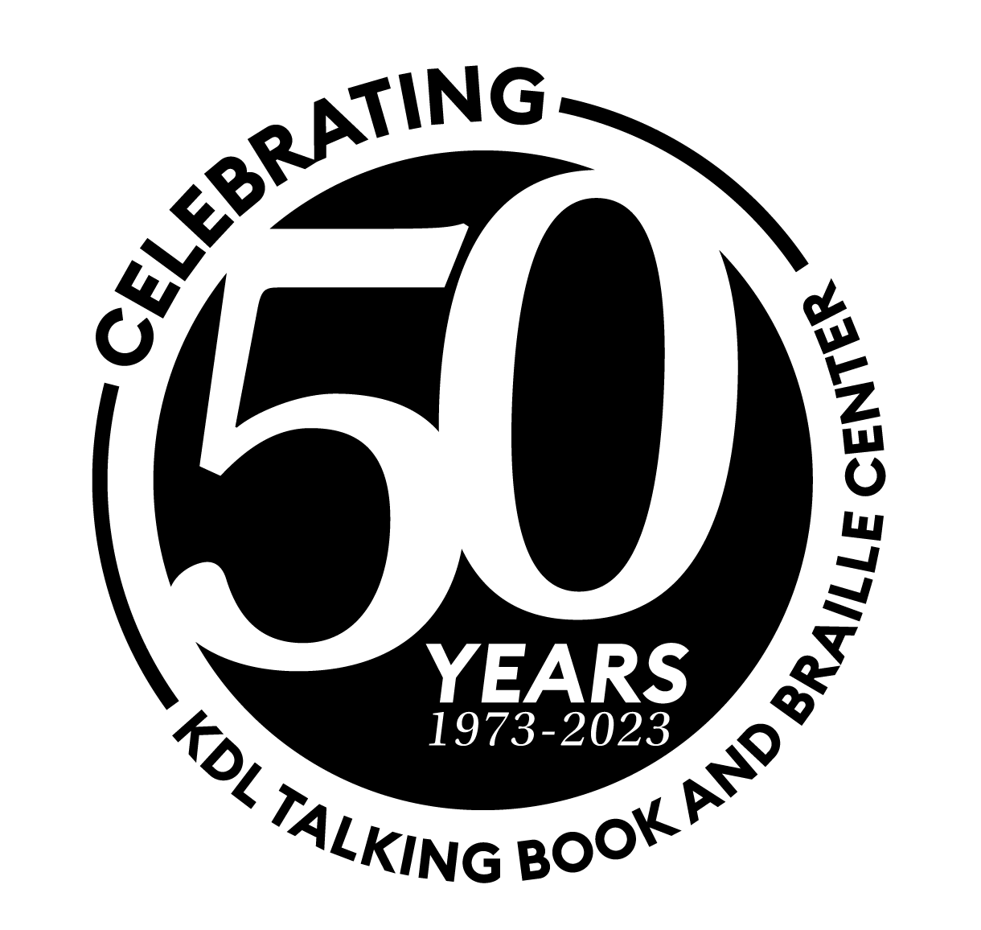
2023 NLS Midlands Regional Conference:

Unity in Diversity

May 16-18, 2023

Grand Rapids, Michigan

Speaker Bios

Jonathan Cauchi
Jonathan Cauchi is a Community Education Specialist at Disability Advocates of Kent County. In this role he provides Disability Awareness training in a variety of settings around the county. Jon has shown a dedication to Disability services as he has worked in that field for the past 10 years, as a Youth Transition Specialist and Recreation coordinator. This passion for working with Disability stems from a personal journey as at age 12 Jon suddenly lost most of his sight to a rare eye disease. His journey has had a lot of twists and turns that came with many lessons of adversity and advocacy. Jon is not one to sit still however as he is father first and foremost, he is also a Youth Camp Director for the Michigan Blind Athletic Association, he sits on the Wyoming City’s Community Development Committee, and is an amateur stand-up comedian. In just about every spare* moment Jon has you can make a safe bet that he has an audio book playing, “Listening to books allowed me to keep books in my life despite my barriers” Disability plays a huge role in Jon’s life but it does not define him.

Samantha Hodge & Marie Mulder
Samantha has worked for Kent District Library for the past 15 years. In 2015, she began work as a Collection Development Librarian and oversees the purchase of the entire adult ficton collection for all twenty branches of the KDL organization. She also served two years on KDL’s Equity, Diversity, and Inclusion Workgroup.
Marie Mulder is a collection development librarian with 18 years of experience working in public libraries. She is passionate about making the library a place in which all people are represented and welcomed.

Amber Strasz
Amber Strasz earned her Master's Degree in Orientation and Mobility from Western Michigan University. She has worked for Macomb Intermediate School District, Grosse Pointe Public School System and Hamtramck Schools. She also contracts for the Michigan Bureau of Services for Blind Persons where she trains adults in O&M skills and leads Pre-ETS workshops for transition age students. She is a Certified Yoga Instructor and Master Gardener Trainee. She has taught yoga to blind and visually impaired youth at Camp T and through Leader Dogs for the Blind. She is also a boy Mom, guy Wife, awesome Aunt, dog Foster, and outdoor enthusiast. This summer she will be directing an International Camp for Blind and Visually impaired Children on the coast of the Black Sea in Turkey.

Christy Buck
With more than 36 years of experience in the mental health field, Christy’s passion for transforming and saving lives through mental health education led her to develop two mental health and suicide prevention programs - be nice. and be nice. Extension. Christy’s determination to make mental health a part of the conversation has led to her involvement with numerous community organizations and coalitions along with becoming a certified instructor for QPR and Mental Health First Aid, for which she has been recognized as one of the Top 100 instructors in the country.

Mandy Mattingly
Mandy Mattingly is currently the Project Director for the ALA-ODLOS and NLS Project for the Revised Standards and Guidelines of Service 2024. She worked as the Youth Services and Outreach librarian at the Washington Talking Book & Braille Library for a few years, before earning a teaching certification and transitioned to the classroom.

