**Appendices**

**A: BARD Download Data Sheet to be Maintained by Library**

**B: Sample TBBC Member Card**

**C: Sample TBBC Mailing Card**

**D: NLS Factsheet: Talking Books and Reading Disabilities**

**E: NLS Fact Sheet: Copyright Law Amendment, 1996**

**F: BARD Pledge**

**APPENDIX A: BARD DOWNLOAD DATA SHEET**

**This Data sheet must be maintained by each library participating in the BARD Pilot Project. It will be collected monthly by TBBC.**



**APPENDIX B: SAMPLE TBBC MEMBER CARD**

**Front of Card (Braille embossed)**

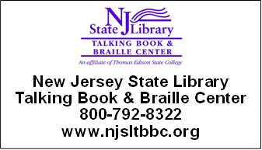

**Back of Card**

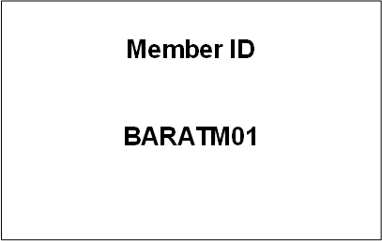

**APPENDIX C: SAMPLE TBBC MAILING CARD**

Each item mailed to a TBBC patron has a mailing card. A patron may bring this card to you to prove his/her TBBC membership.

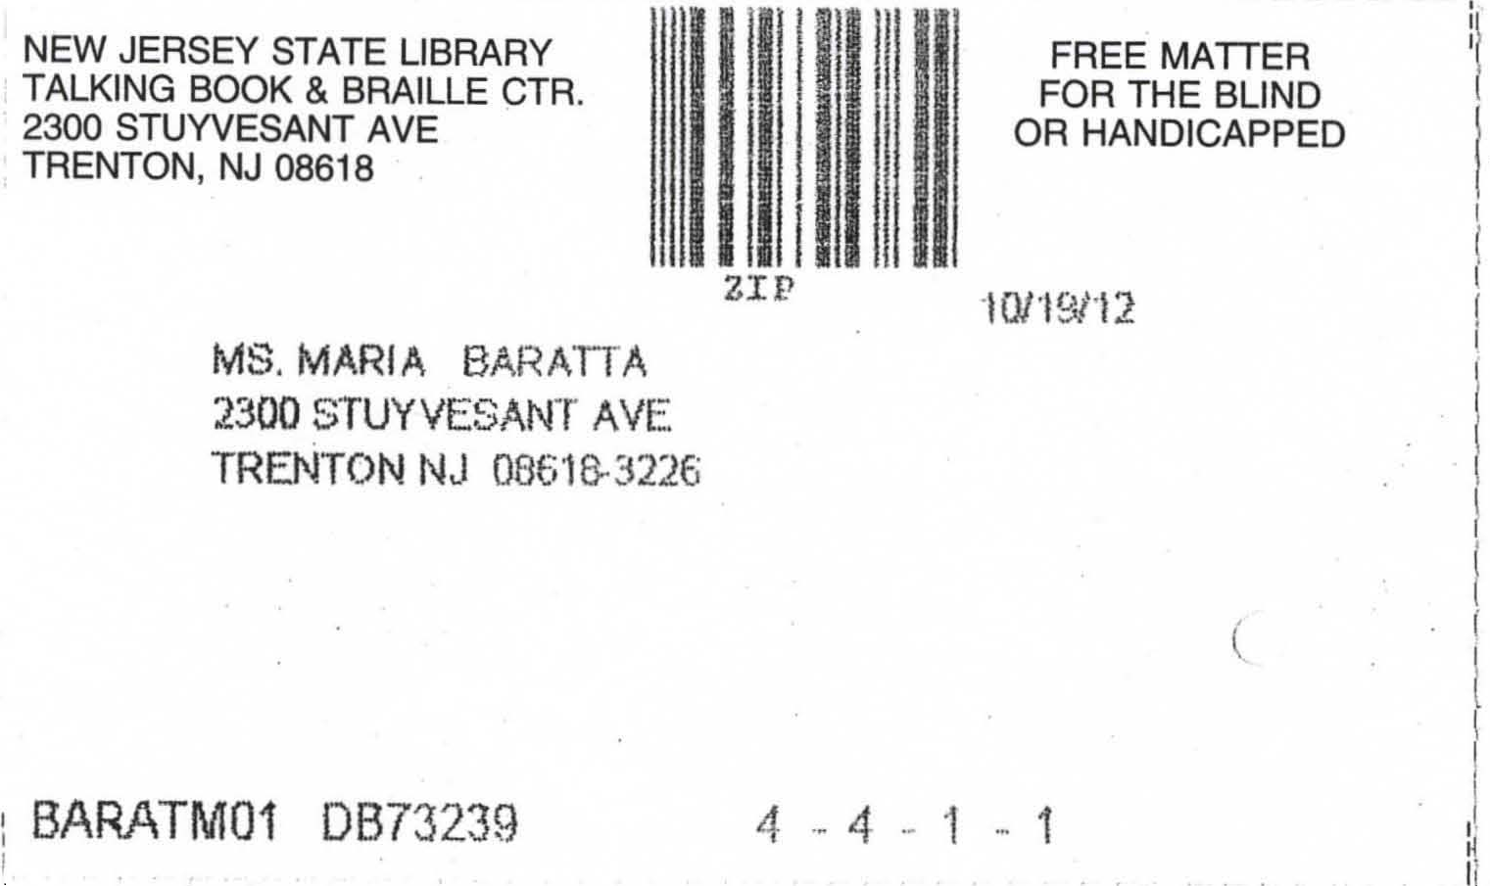

**APPENDIX D: NLS FACTSHEET: TALKING BOOKS & READING DISABILITIES**

Downloaded 10/17/12 from: <http://www.loc.gov/nls/reference/factsheets/readingdisabilities.html>

NLS Factsheets: Talking Books and Reading Disabilities

Web version revised September 19, 2012.

Original document posted 2010.

Background

The National Library Service for the Blind and Physically Handicapped (NLS), Library of Congress, administers a free national library program for visually and physically handicapped persons who cannot use normal print library material. Under a special exemption of the U.S. copyright law and with the cooperation of authors and publishers who grant permission to use noncovered copyrighted works without royalty, NLS selects and produces full-length books and magazines on recorded disc and cassette and in braille. Reading materials are distributed to a network of cooperating regional and subregional libraries where they are circulated to eligible borrowers. Special playback equipment is needed to listen to books and magazines on cassette and disc because they are recorded to play at speeds of 15/16 ips for cassettes and 8-1/3 rpm for discs, which are slower than standard speeds. Reading materials and machines are sent to borrowers and returned to libraries by postage-free mail. The book collections consist of recreational and general informational reading for adults and children at all reading levels. Books are selected on the basis of their appeal to a wide range of interests and include bestsellers, biographies, and general fiction and nonfiction.

The NLS collections are recorded for visually or physically handicapped adults and children, those who are physically handicapped to such a degree that their impairment makes it difficult or impossible for them to hold a book, turn the pages, or read standard print. Each book is narrated without background music or special sound effects. The materials at any given reading level are not geared to children or adults with short attention spans or to those who need high-interest, low-vocabulary books. Textbooks and curriculum-oriented and remedial reading materials are not included in the NLS book collections.

Public Law 89-522

The NLS program was established by an act of Congress in 1931 to serve blind adults. The program was expanded in 1952 to include blind children and in 1966 by Public Law 89-522 to include individuals with physical impairments that prevent the reading of regular or standard print.

Eligibility of Persons with Reading Disabilities

Public Law 89-522 states that materials will be loaned to readers "certified by competent authority as unable to read normal printed material as a result of physical limitations, under regulations prescribed by the Librarian of Congress for this service." The current federal regulation for this program is set forth in the Federal Register for June 7, 1974, as amended October 2, 1981. Individuals with reading disabilities are not expressly covered by this statute. Under Public Law 89-522, only persons whose reading disabilities are physically based are eligible for the NLS talking-book program. Furthermore, the reading disability must be certified by competent authority, described below, as having a physical basis before an applicant is considered for the talking-book program. An individual whose reading disability does not have a physical origin is not eligible.

Applications for service from individuals claiming a reading disability based on a physical handicap must establish the following facts:

•the reading disability must be of sufficient severity to prevent reading regular or standard printed material in a normal manner,

•the cause of the disability must be physically based, that is, it must be an organic dysfunction, and

•the person certifying the application must be medically able to judge whether the disability has a physical or organic basis.

The following groups of individuals are not automatically eligible: those who have learning disabilities, dyslexia, attention deficit disorder, attention deficit-hyperactivity disorder, chronic-fatigue syndrome, autism, functional illiteracy, or mental retardation, unless there is a specific accompanying visual or physical handicap.

Competent Authority

For most eligible people served by this program, the cause of the inability to read printed material-such as blindness, paralysis, loss of arms or hands, extreme weakness, or palsy-is readily observable. In these cases, professionals in various fields related to health care, education, or rehabilitation are acceptable as certifying authorities. With persons classified as reading disabled, usually only the effect is readily apparent. The cause, when physical, lies within the central nervous system, and, under the existing regulation, this cause can be determined only by competent medical authority.

The signature of a doctor of medicine or doctor of osteopathy is required by federal regulation on the application to certify not only that a reading disability exists and is serious enough to prevent reading regular printed material in a normal manner, but also that the identified condition has a physical basis. Nonorganic factors-such as emotional or environmental causes, intellectual or educational deficiencies, or other possible nonorganic or nonphysical causes-must be ruled out and cannot be taken into consideration. When certifying applications for service for persons with reading disabilities, certifying medical authorities are encouraged to consult with colleagues in associated disciplines.

Application Procedure

A standard application form and additional information about this free library service may be obtained from any regional or subregional library for the blind and physically handicapped. Individuals may also write to the National Library Service for the Blind and Physically Handicapped, Library of Congress, Washington, DC 20542 or e-mail nls@loc.gov to request an application form and the addresses of cooperating libraries. The completed application, signed by a doctor of medicine or doctor of osteopathy in the case of a reading disability, should be submitted to the cooperating library serving the applicant's geographic area.

Learning Ally (formerly Recording for the Blind and Dyslexic) Program

Learning Ally (formerly Recording for the Blind and Dyslexic [RFB&D]) is a private organization that lends recorded textbooks and other educational materials to people who cannot read standard print because of visual, perceptual, or other physical disability. There is a registration fee and an annual membership fee for Learning Ally service. Learning Ally does not lend playback equipment to its patrons. Information about the Learning Ally program its eligibility requirements, and applications for service are available from: Learning Ally, 20 Roszel Road, Princeton, NJ 08540, (609) 452-0606, 800-221-4792, (609) 987-8116 fax, <http://www.learningally.org> .

Some individuals with learning disabilities who are already receiving service from Learning Ally apply for the NLS talking-book program to obtain playback equipment. They expect that the Learning Ally membership will guarantee eligibility for service from NLS. However, Learning Ally has its own eligibility criteria for persons with specific learning disabilities; these criteria differ from the NLS requirements. Learning Ally has more flexibility in its policies because it is a private, nonprofit organization; NLS, however, can provide service only to those who meet the federal statutory requirements.

NLS cooperating network libraries can lend playback equipment to individuals who: (1) meet the eligibility requirements of the NLS program, which include providing a detailed application, certified as required by NLS regulations described above; and (2) will actively borrow and use NLS reading materials. The playback equipment provided by NLS is intended for use with the general-interest reading materials NLS provides; it is not assigned to patrons to meet academic needs. Such needs should be discussed with local educational authorities. Individuals receiving Learning Ally books who are not eligible for loan of NLS equipment must obtain their own playback equipment. Suitable equipment for Learning Ally books is available for purchase from a number of sources, including Learning Ally. Contact the NLS Reference Section for information about such sources and about other resources available for individuals with reading disabilities. (Reference Section, NLS/BPH, Library of Congress, Washington, DC 20542, (202) 707-9275, (202) 707-0712 fax).

Summary

To fulfill the NLS statutory obligations, assure the continuity of this program, observe the copyright law and the agreements that furnish NLS with cost-free copyright permission, and protect the "free matter for the blind and handicapped" mailing privileges, NLS must ensure conformance with the regulations governing this program. If you have any questions about the eligibility and certification of those with reading or learning disabilities, please refer them to:

Chief, Network Division

National Library Service

for the Blind and Physically Handicapped

Library of Congress

Washington, DC 20542

**APPENDIX E: NLS FACTSHEET: COPYRIGHT LAW AMENDMENT**

Downloaded 10/17/12 from: <http://www.loc.gov/nls/reference/factsheets/copyright.html>

NLS Factsheets: Copyright Law Amendment, 1996:

PL 104-197 December 1996

Background

The free national library program of reading materials for visually handicapped adults administered by the National Library Service for the Blind and Physically Handicapped (NLS), Library of Congress, was established by an act of Congress in 1931. The program was expanded in 1952 to include blind children, in 1962 to include music materials, and in 1966 to include individuals with physical impairments that prevent the reading of standard print.

From the beginning, this program was dependent upon the cooperation of authors and publishers who granted NLS permission to select and reproduce in special formats copyrighted works without royalty. Although many factors influence the length of time it takes to make a print book accessible in a specialized format, the period required to obtain permission from the copyright holder has sometimes been significant.

Public Law 104-197

Under the Legislative Branch Appropriations Bill, H.R. 3754, Congress approved a measure, introduced by Senator John H. Chafee (R-R.I.) on July 29, 1996, that provides for an exemption affecting the NLS program. On September 16, 1996, the bill was signed into law by President Clinton.

The Chafee amendment to chapter 1 of title 17, United States Code, adds section 121, establishing a limitation on the exclusive rights in copyrighted works. The amendment allows authorized entities to reproduce or distribute copies or phonorecords of previously published nondramatic literary works in specialized formats exclusively for use by blind or other persons with disabilities.

The act making appropriations for the Legislative Branch for the fiscal year ending September 30, 1997, sets forth the Chafee amendment as follows:

Be it enacted by the Senate and House of Representatives of the United States of America in Congress assembled, that . . . and for other purposes, namely:

(a) IN GENERAL--Chapter 1 of title 17, United States Code, is amended by adding after section 120 the following new section:

"SEC.121. Limitations on exclusive rights: reproduction for blind or other people with disabilities

"(a) Notwithstanding the provisions of sections 106 and 710, it is not an infringement of copyright for an authorized entity to reproduce or to distribute copies or phonorecords of a previously published, nondramatic literary work if such copies or phonorecords are reproduced or distributed in specialized formats exclusively for use by blind or other persons with disabilities.

"(b)

(1) Copies or phonorecords to which this section applies shall--

"(A) not be reproduced or distributed in a format other than a specialized format exclusively for use by blind or other persons with disabilities;

"(B) bear a notice that any further reproduction or distribution in a format other than a specialized format is an infringement; and

"(C) include a copyright notice identifying the copyright owner and the date of the original publication.

"(2) The provisions of this subsection shall not apply to standardized, secure, or norm-referenced tests and related testing material, or to computer programs, except the portions thereof that are in conventional human language (including descriptions of pictorial works) and displayed to users in the ordinary course of using the computer programs.

" (c) For purposes of this section, the term--

"(1) 'authorized entity' means a nonprofit organization or a governmental agency that has a primary mission to provide specialized services relating to training, education, or adaptive reading or information access needs of blind or other persons with disabilities;

"(2) 'blind or other persons with disabilities' means individuals who are eligible or who may qualify in accordance with the Act entitled 'An Act to provide books for the adult blind', approved March 3, 1931 (2 U.S.C. 35a; 46 Stat. 1487) to receive books and other publications produced in specialized formats; and

"(3) 'specialized formats' means braille, audio, or digital text which is exclusively for use by blind or other persons with disabilities.".

(b) TECHNICAL AND CONFORMING AMENDMENT--The table of sections for chapter 1 of title 17, United States Code, is amended by adding after the item relating to section 120 the following:

"121. Limitations on exclusive rights: reproduction for blind or other people with disabilities.".

--------------------------------------------------------------------------------

Questions and Comments Raised by the Chafee Amendment

What is the effective date of the amendment?

H.R. 3754 does not specify an effective date. Therefore, the effective date is September 16, 1996, the date on which the president signed the bill.

Are the provisions of the amendment retroactive?

The exemption covers all nondramatic literary works protected by copyright regardless of when they were first published, but reproduction and distribution under the exemption must take place on or after September 16, 1996, the effective date of the amendment.

Does the amendment cover periodicals?

The new exemption covers "nondramatic literary works"; section 101 of title 17 includes "periodicals" within the definition of "literary works." Therefore, the amendment covers periodicals.

If a book is involved in litigation, will the exemption apply?

Nothing in the Chafee amendment withdraws the exemption in case of litigation. However, in the event that NLS is notified that a federal court has issued a final decision, holding that the work is an unauthorized publication and recall of copies is required, NLS will withdraw all copies of the infringing work.

Is a published script of a play considered a "nondramatic literary work?"

A published script of a play would be considered a "dramatic work" or alternatively a "dramatic literary work" and would be outside the amendment, which covers only "nondramatic literary works." Therefore, NLS will continue to seek permission from the copyright holders to reproduce and distribute plays.

What does "authorized entity" include?

The amendment defines and limits "authorized entity" to "a nonprofit organization or a governmental agency that has a primary mission to provide specialized services relating to training, education, or adaptive reading or information access needs of blind or other persons with disabilities." A "nonprofit organization" is understood to mean an organization that has been granted nonprofit tax exemption under section 501(c)(3) of the Internal Revenue Code.

To the extent that authorized agencies and organizations use or delegate authority to volunteers, special education teachers, and commercial producers under government contract to produce and distribute works under the exemption, those activities appear to be fully covered by the exemption. Such individuals can be said to be agents of authorized entities and are, therefore, acting under implied authority. The activities of individuals not connected to those specialized agencies and organizations fall outside the exemption.

Is copyright permission required for works published simultaneously in the United States and elsewhere?

All works protected by U.S. copyright law, including those first published abroad or in multiple editions published in several countries, are subject to the exemption for activities undertaken by authorized entities within the United States. Section 104 of title 17 sets out the eligibility requirements for U.S. copyright law protection. For further information, obtain Circular 38a from the Copyright Office.

NLS produces braille and recorded versions of books published and copyrighted abroad. Under the Chafee amendment, will permission from foreign copyright holders be required?

All works protected by U.S. copyright law, including those first published abroad, are subject to the exemption. Thus, permission from foreign copyright holders for reproduction and distribution in the United States under the exemption is not required. If the braille or recorded versions of the books were distributed outside the United States, however, such act of distribution would not be covered by the exemption since U.S. copyright law has no extraterritorial effect. Since NLS loans material to eligible foreign agencies, NLS will continue to request permission for all books and periodicals published outside the U.S.

Must foreign agencies who purchase NLS books continue to obtain copyright clearance?

Foreign agencies who purchase NLS books must continue to obtain copyright clearance. The principle with respect to this is the same as described above. The exemption applies only to activities within the United States.

Will foreign countries still be able to purchase magazines that NLS produced in special formats?

As the previous answer indicates, the exemption will not apply to activities conducted abroad. Therefore, foreign agencies will have to seek their own individual written copyright permissions from the copyright holders before NLS will permit the purchase of copies of master recordings of audio magazines reproduced by NLS under the new exemption.

Must producers continue to add "all rights reserved" to the standard copyright notice that is currently placed at the beginning of books reproduced in special formats?

No, this is not required. The "all rights reserved" copyright notice originated in the Buenos Aires Convention of 1910. The effect of this Convention in the United States has always been unclear. Since the United states joined the Berne Convention in 1989, there clearly is no need to include this statement.

Does "bear a notice" refer only to announcements or does it include the print label affixed to all copies and phonorecords?

Section 121 of title 17 has two notice requirements; it provides that the copies or phonorecords produced under the exemption shall (1) "bear a notice that any further reproduction or distribution in a format other than a specialized format is an infringement," and (2) "include a copyright notice identifying the copyright owner and date of the original publication."

The copyright law has contained notice requirements for many years; those requirements have always been understood to mean a written notice. The previous copyright law contained a provision that said "copies of the work shall bear the symbol © accompanied by ... " Thus, the use of the word "bear" has been understood to mean that the copies have affixed to them a written copyright notice. In the 1976 copyright act, sections 401 and 402 of title 17 provided for the placement of a notice of copyright on visually perceptible copies and on the surface, label, or container of phonorecords of sound recordings.

Consequently, NLS will (1) include both of the required notices, in print, on all braille copies and on all phonorecords of sound recordings, and (2) include both notices in audible form on all sound recordings.

Does "specialized format" include the NLS-produced instructional music cassettes recorded at the standard commercial speed of 1-7/8 ips rather than NLS's customary 15/16 ips speed?

The exemption does not include music, nor does it cover recorded material that is not in a "specialized format."

NLS compiles a music magazine containing articles reprinted from national periodicals. Are magazines that are produced in large print, braille, and recorded formats covered by the exemption?

The exemption defines "specialized format" as "braille, audio, or digital text which is exclusively for use by blind or other persons with disabilities." Works reproduced in large print are, therefore, not included under the exemption.

Where should questions concerning the Chafee amendment be directed?

Questions originating from the media should be directed to the Library of Congress Public Affairs Office at (202) 707-2905. Contact the Library of Congress Copyright Office Public Information Office at (202) 707-3000 for other general questions.

NLS currently lends books through interlibrary loan (ILL) to foreign agencies serving blind and physically handicapped individuals. Will this practice continue, or will ILL be limited to books for which NLS has received copyright permission?

NLS will continue to lend to eligible foreign agencies through interlibrary loan. Such distribution is permissible under U.S. law and is unlikely to infringe the laws of other countries.

However, foreign agencies must look to the law of the country where the use takes place to determine whether they might be liable for acts of unauthorized importation or distribution of lawfully made copies without permission of the copyright owner.

**APPENDIX F: BARD PLEDGE**

**Approximately once per month, each BARD user will be asked to take the BARD pledge when they log into BARD.**

Downloaded from: <https://nlsbardpractice.loc.gov/nlsbardpractice/LOC_02/bardhandbooks/revision3/web/Pagesforsection1Patron/BARD%20user%20pledge.htm>

**BARD user pledge**

Participants must agree to our pledge:

National Library Service for the Blind and

Physically Handicapped Download Agreement

I understand and agree to the following:

The texts embodied in the braille and recorded materials supplied

by the National Library Service for the Blind and Physically

Handicapped, Library of Congress are reproduced and distributed

in specialized formats exclusively for use by blind and other

persons with disabilities under the authority of 17 U.S.C.

section 121 or with permission of the copyright owner(s). Any

further reproduction or distribution of the braille or recorded

materials may constitute infringement of copyright.

Use of NLS-produced materials is limited to eligible NLS readers

and institutions. Access to the NLS Braille and Audio Reading

Download web site outside the United States, except by eligible

American citizens, is not permitted. Downloaded files or any

files generated from them may not be distributed or sold under any

circumstances. Transferring original or modified files to anyone

is prohibited. User IDs and passwords may not be shared with

anyone. The Library of Congress actively monitors the NLS system

to protect against this, which includes maintaining records of

the identity of persons downloading materials from this web site.

Readers engaging in or facilitating further reproduction or

distribution of NLS-produced materials may have their privileges

under the National Library Service program suspended or revoked,

may be required to surrender the federal property in their

possession, and may be subject to other penalties, including

criminal penalties, afforded under federal law.